Person | Country | Century | Idea | How did this change society?
Nicolaus
Copernicus
Galileo
Galilei
Johannes
Kepler
Isaac
Newton
John
Locke
Voltaire
Jean-Jacques
Rousseau
Thomas
Jefferson
Adam
Smith
Karl
Marx

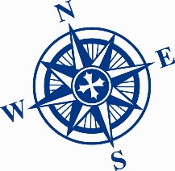
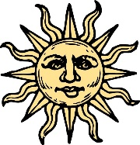
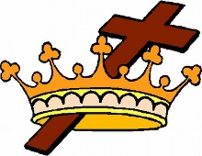
Who was the most inflammatory SCIENTIST? | Who was the most inflammatory PHILOSOPHER? | Who was the most inflammatory RULER?

