Empires of Mesopotamia Notes
Babylonians (1800-900 BC) | Assyrians (900-600BC)
Neo Babylonians (600-540BC) | Persian Takeover (539BC)
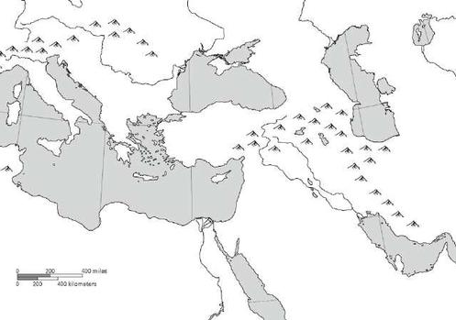
Map Key
Babylon
Assyria
Neo-Babylon
Persia

