Spanish-Speaking South America
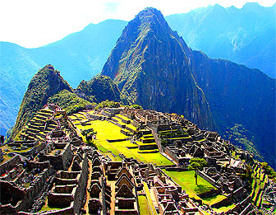
One of the great civilizations of the Americas arose in the rugged Andes Mountains. The civilization was created by the Inca. They built their empire on the foundation of earlier civilizations. After they built their capital, Cuzco in Peru, they extended their power. By 1500, the Inca Empire extended 2,500 miles along the west coast of South America (from Ecuador to Argentina). It was all connected by 20,000 miles of roads -- which is even MORE impressive because the Inca didn’t even have wheels!
In 1532, Pizarro with only 180 men, took over Peru and destroyed Inca Empire. The Inca were centered at Manchu Pichu in Peru. Their leader, Atahualpa, did NOT think that the Spanish were gods, but thought he scared them away. The Spanish attacked at the Inca’s victory celebration. They wanted the Inca silver and gold.
They forced the Inca to work in mines, farms, and ranches. The Spanish abused many of the Inca, even though they were supposed to be treating them humanely (kindly) and showing them how good Christians behaved. The Inca eventually stopped living in villages and moved to large plantations. This broke up families. The familial breakup is reflected in the often abusive governments in the region. They also made the Inca stop speaking their language, Quechua, and start speaking Spanish. The Spanish also forced the Inca to convert to Catholicism.
Europeans contact with the Natives of North & South America led to the Colombian Exchange (the trade of animals, plants, culture, human populations, technology and ideas between North America, South America, Europe, Asia, and Africa). The Spanish brought Gunpowder, Horses & other “farm” animals, Christianity, Slaves, Wheat, Oranges, Bananas, Coffee, Rice, Sugar, AND diseases like Smallpox (that killed up to 95% of Natives). The Natives gave the Europeans Corn, Potatoes, Tomatoes, Peppers, Pumpkins, Squash, Chocolate, Turkey, Tobacco.
The culture of South America is very unique, in part because it was isolated in the Andes Mountains. These countries formed a cultural mosaic (societies with different cultures that are independent but sometimes mix). Most people in the region are ethnically Mestizo (Spanish & Native). The art of the area is mostly Spanish and Native influenced. Spanish-Speaking South America has had a strong literary heritage. In the 1970s and 1980s, many famous novels were written, like One Hundred Years of Solitude by Gabriel Garcia Marquez. These novels often contain dream-like elements (which was a tradition of the Inca). Beautiful ponchos are still made by Native weavers from indigenous (native) animals, such as llamas and alpacas
The average person’s daily language still is influenced by the Inca, too. The second-most popular language in these countries is still Quechua. The historical importance of the exotic Quechua language is reflected in the names as Aconcagua ("white sentinel"), the tallest peak in the New World; Huascarán (named for an Inca chieftain); and Illampú (snow), as well as that of the Andes themselves (one theory suggest that the name comes from the Quechua word for "copper," which is found in abundance in the area). Quechua even has official status in Peru and Bolivia alongside Spanish. In Bolivia, Aymara (another Native language) is also official.
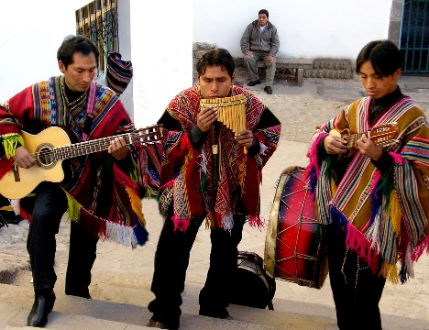
The music of this area blends African, Native, and European elements. The African influence is mostly a result of being near countries with large African-decedent (grandchildren and great-grandchildren) populations. There wasn’t as much African-based slavery in this region because all the mountains didn’t leave much room for big plantations. Caribbean African rhythms blend with Spanish-influenced music. Musicians play instruments from all 3 cultures: European (guitars, flutes), African (drums, marimbas), and Native (maracas). Folk art and pottery is often decorated with Inca symbols.

