Central America & the Caribbean
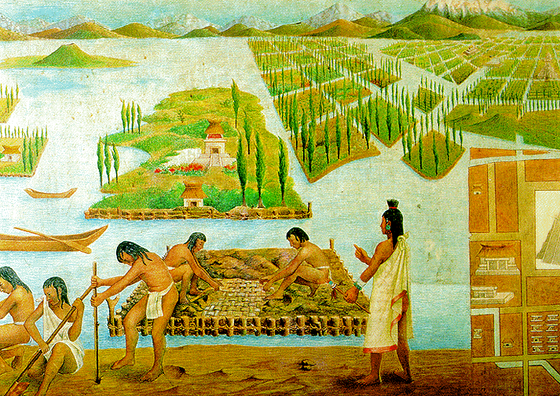
Central America is a cultural hearth (a place where important ideas start). The Mayan people build a great civilization in the area that spread throughout the region. The homeland of the Maya stretched from southern Mexico into Northern Central America. But in the 800s, the Maya disappeared. The legacy of the Maya is still around. They built many pyramid-shaped temples. The temples in Guatemala were the tallest structures in the Americas until the 20th century. The Aztec people soon replaced the Maya. The Aztec practiced human sacrifice of their enemies to their gods & built chinampas (man-made floating islands). The Aztecs were led by the great Montezuma II.
In 1519, Hernando Cortés captured and destroyed the beautiful capital Aztec city “Tenochtítlán”. All the temples, art, and gardens were gone. It was renamed by Spanish as Mexico City. Part of the reason for their downfall is because they thought Cortes was their god named “Quezquotal”, who was supposed to return from across the ocean that year.
Europeans contact with the Natives of North & South America led to the Colombian Exchange (the trade of animals, plants, culture, human populations, technology and ideas between North America, South America, Europe, Asia, and Africa). The Spanish brought Gunpowder, Horses & other “farm” animals, Christianity, Slaves, Wheat, Oranges, Bananas, Coffee, Rice, Sugar, AND diseases like Smallpox (that killed up to 95% of Natives). The Natives gave the Europeans Corn, Potatoes, Tomatoes, Peppers, Pumpkins, Squash, Chocolate, Turkey, Tobacco.
The Spanish conquest (take over) of the Aztecs in Mexico allowed them to take over the rest of Central America. By the 1800s, the Spanish, French, British, Dutch, and Danish rulers had taken over all the islands in the Caribbean. For hundreds of years, the whole region was run by the kings and queens of Europe. However, they were not the only important ethnic group in the region. The Natives of the Caribbean (the Taino) were the first to be conquered by the Spanish. The Aztec and Taino were forced to work on sugar plantations, but many died of disease.
To replace the natives, European slave traders brought Africans slaves to work on the sugar plantations. As a result, this region has a strong mix of European, Native, and African influence (ideas & culture). The Spanish were the dominant (main) group of European settlers in Central America. That’s why the majority of people speak Spanish. In Haiti, they speak French. In Jamaica, they speak English. The people of Central America also converted to Catholicism like the Spanish. The Spanish also changed the way of life of the Taino and Aztecs. They practiced deforestation (cut down forests) and told people to move to farms or towns.
Mexico has a Mestizo (Spanish & Native) population. The heritage of the Native people is still very strong. Mexico’s public murals (wall-length paintings) show off scenes of the country’s history. Diego Rivera made many famous murals depicting the ancient city of Tenochtítlán. There are still some people who practice Maya religious ceremonies.
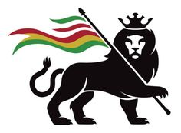
African influence was very important in the Caribbean islands. Most people in the Caribbean islands are descendants (grandchildren & great-grandchildren) of the African slaves brought to work on the sugar plantations. The religion of the Caribbean includes Catholic & Protestant, as well as Santeria (a religion that mixes Catholicism & African rituals). Voodoo (another religion that mixes Catholicism & African rituals) is practiced in Haiti. Rastafarianism (a religion that began by calling the king of Ethiopia the black Messiah who would free Africans everywhere) is a religious and political movement in Jamaica.

