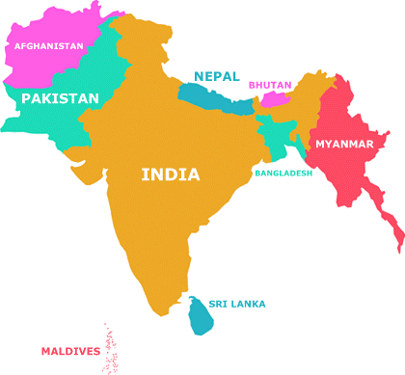**Asia WordSearch Puzzle**

R I V M L L E E F L W P U M H R G P P C   
M E M E H X F V G R J H E A U P A R L S   
R O Q I P L I O M E A E B F I G I A M B   
G I X E F E C N S M D J N K P M H M S G   
Z S A M C B M G D H F J E U H H Q A V A   
U A X T O O O P C U L M P S M I A D L N   
J T F L P N E C E A S B A H A N U A B G   
R F H Q G C S K T F S K L L T D V N M E   
I Q F K E I G O B H U T A N D U E C E S   
L R L A Q M A A O S E D E E R I A F R I   
E C L P S O K I G N N L S Y Q S V M T D   
Z J I B E N G A L A O J C D H M H E G D   
D G N D A A L E M I B A N G L A D E S H   
O D D L H R K H V A R A H I M A L A Y A   
G N I F A C R N V E L J K K L R O C M R   
R R A C N H O O T G H A N D I R R E Z T   
S U B C O N T I N E N T Q O U I T S A H   
T B L B E M L E T E R R J O S H E R P A   
O M J O W L S L B X T M M A M K F V E W   
R P A K I S T A N L E T R G I X A A E R

Find the following hidden words:

himalaya,

subcontinent,

monsoon,

hinduism,

ganges,

mughal,

raj,

caste,

kashmir,

ramadan,

indus,

sherpa,

siddhartha,

mandala,

monarch,

illiteracy,

pakistan,

india,

nepal,

bhutan,

bangladesh,

srilanka,

maldives,

kush,

bengal,

ghandi,

england,

nonviolent,