Ancient Egypt
While the Sumerians, Babylonians, Akkadians and other groups were busy creating a Mesopotamian civilization in the Fertile Crescent of the Ancient Near East, another civilization had appeared to the west. It was the fertile valley of the Nile River that allowed Egyptian civilization to flourish over the course of many centuries. It is an area of the world in which much needed natural resources were abundant. Furthermore, because it is in the Sahara Desert, the climate of Egypt is very dry and almost changeless. Because of this static, changeless quality, the Egyptians obtained a sense of security from their environment.
Because of the predictable flooding of fields, and a little irrigation, The Egyptians maintained a largely vegetarian diet. Meat was expensive, could not last long as there was no concept of refrigeration, and so was primarily reserved for nobility, the wealthy, and for festivals and special occasions. Animals used for meat included cattle, lambs, sheep, goats, ducks, sometimes pigs or fish, and for the nobles, antelope killed in the hunt. The staple crops of ancient Egypt were emmer (a wheat-grain), chickpeas and lentils, lettuce, onions, garlic, sesame, corn, barley, and papyrus. In fact, Egypt was so good at farming that it shipped its produce to Mesopotamia, the Levant, India, Nubia (modern-day Sudan), and the Land of Punt (modern-day Somalia) among others.
They borrowed more than just irrigation from the Mesopotamians. Although the idea of writing may have come from Mesopotamia, the script was independent of the cuneiform. Egyptian writing began as pictographic and was later combined with sound signs to produce a difficult and complicated script that the Greeks called hieroglyphics ("sacred carvings"). Though much of what we have today is preserved on wall paintings and carvings, most of Egyptian writing was done with pen and ink on fine paper (papyrus).
Egyptian religion, like that of Mesopotamia, was polytheistic and each region had its own patron deity. As a rule, whenever a new capital was founded, a new supreme god was chosen. The Pharaoh was always important, for he was not only the mediator between men and the gods, but was himself divine. Pharaoh's rule was eternal and absolute – he ruled not just for the gods, but as a god himself.
Egyptian gods were often represented as animals – as falcons, vultures, a cobra, dog, cat or crocodile. For the Egyptians, because animals were non-human, they must have possessed religious significance. Other gods, such as Ptah and Amon, were given human representation, but the most important god Ra, was not represented at all. The gods created the cosmos – they created order out of chaos. The Sumerians had a similar belief. But the life of the Sumerian was filled with anxiety and pessimism because the gods themselves were unstable and the idea of an afterlife was unknown.
Egyptian religion inspired confidence and optimism in the external order and stability of the world. The gods guided the rhythms of life and death. And what really distinguished Egyptian religion from that of Mesopotamia, was that any man or woman could share in the benefits of an afterlife!
The great pyramids of Giza, built more than 4500 years ago, expressed pharaoh's immortality and divinity. The pyramids were completely inaccessible structures – once pharaoh was buried, hallways and passages were sealed and obliterated. One of the most compelling features of the pyramids, in addition to the architectural feat of just building them, was their mortuary art. Inside the pyramids was the royal burial chamber. The walls of the chamber are covered with hieroglyphics, which detail the life of pharaoh. We find art detailing people fishing and hunting. We also see people seated at banquets. Representations of food and wine were included as well. Jars of wine, grain, fruits and other foods were included, as well as boats, bows, arrows, jewelry, and other objects from the real world. Slaves were often entombed as well. Why? Very simple. Pharaoh would need these things in the afterlife, since death was not final, but an extension of this worldly life. Death was nothing final but the beginning of yet another cycle. In the next life there would be birds, people, oceans, rivers, desert, food and wine.
From what we have said so far it should be obvious that religion gave the river civilizations of Mesopotamia and Egypt their distinctive character. But this religion was not a religion of comfort or morality. Instead, these polytheistic religions were mythopoeic. Whereas our world view may be scientific or rational, these river civilizations adopted a world view based on myth. The construction of myths was the first manner in which western civilization attempted to explain life and the universe. Myths explained the creation of the universe as well as the role men and women would play in that universe. Nature, for these earliest river civilizations, was not an inanimate "it." Instead, nature, the world of nature, had a life, will and vitality all its own.
The myth-makers of the Ancient Near East and of Egypt did not seek to rationally or logically explain nature. Instead of natural laws or systematic explanations, these people resorted to divine powers and myths. Although these civilizations certainly exercised their minds to build ziggurats and pyramids, irrigation canals and pottery wheels, cuneiforms and hieroglyphics, they did not advance to the creation of the sciences as a subject. They did not deduce abstractions, nor did they make hypotheses or establish general laws of the nature world. These efforts – science and philosophy – were the product of another culture, located in another time and place: the Greeks.

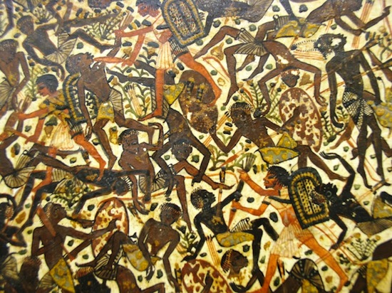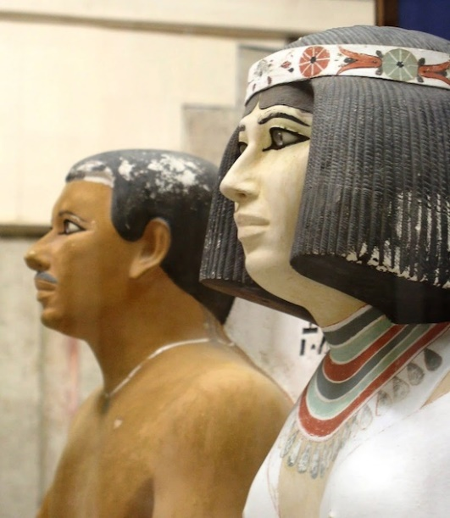
Even the art in Ancient Egypt was religious in nature. It was not intended to be seen, but was made by family of the deceased to show to the gods what kind of person they were. In addition to the static, side pictures you usually associate with Egypt, the pyramids also included great battles (left) and daily interactions between family (right).

Hebrew Civilization
Dwarfed by the great empires of the Sumerians, Akkadians, Babylonians and Egyptians, were the Hebrews. Of all the ancient civilizations, it was the Hebrews who exerted perhaps the greatest influence on western society as well as the western intellectual tradition.

The Hebrews, a Semitic-speaking people, first appeared in Mesopotamia. For instance, Abraham's family were native to Sumer. But between 1900 and 1500 B.C., the Hebrews migrated from Mesopotamia to Canaan and then into Egypt. At this time, a tribe of Hebrews who claimed to be the descendants of Abraham began to call themselves Israelites ("soldiers of God"). The Hebrews were enslaved by the Egyptian pharaohs until 1250 B.C. when their leader, Moses, led them on an exodus out of Egypt to the Sinai peninsula. Moses persuaded his followers to become worshippers of Yahweh or Jehovah.

The Hebrews who wandered into the Sinai with Moses decided to return to Canaan. The move was not easy and the Hebrews were faced with constant threats from the Philistines who occupied the coastal region. Twelve Hebrew tribes united first under Saul and then his successor, David. By the 10th century, David and his son Solomon had created an Israelite kingdom. Economic progress was made as Israeli people began to trade with neighboring states. New cities were built and one in particular, Jerusalem, was built by Solomon to honor God.

In 586, the region of Judah was destroyed and several thousand Hebrews were deported to Babylon. (200 years earlier the northern country of Israel was destroyed by the Assyrians. The 586 destruction completed the destruction of the two regions.) The prophets Isaiah, Ezekiel and Jeremiah declared that the Babylonian captivity was God's punishment. The Hebrews, in other words, had brought upon their own captivity because they had violated God's laws. Despite this calamity, the Hebrews survived as people. In the 4th century, Alexander the Great conquered nearly all of the Near East and Palestine was annexed to Egypt and fell under Greek control. And by the 1st and 2nd centuries B.C., the Hebrews lost near total independence under the Romans. But the Hebrews would never give up their faith or their religion.

The Hebrews were, as a people, committed to the worship of one God and His Law as it was presented in the Old Testament. The Old Testament represents an oral history of the Jews and was written, in Hebrew, between 1250 and 150 B.C. The Old Testament was written by religious devotees and not by historians – it therefore contains factual errors, discrepancies and imprecise statements. Still, much of the 39 books of the Old Testament are also reliable as history. No historian who wishes to understand the religious faith of the Jews can do so without mastering the Old Testament.

There is only one god in the Old Testament – although the books of the Old Testament emphasize the values of human experience. Its heroes are not gods and goddesses but men and women, both strong and weak. What separates the religious beliefs of the Hebrews from the belief systems of Egypt or Mesopotamia was clearly their monotheism. The Hebrews regarded God as fully sovereign – He ruled all and was subject to no laws Himself. Unlike Near Eastern gods, Jehovah was not created – God is eternal and the source of all creation in the universe. He created and governed the world and shaped the moral laws that govern humanity.

God was transcendent – that is, He is above nature and not part of nature. In this sort of religion, there is no place for a sun god or moon god. Nature was demystified – it was no longer super-natural, but natural. That is, the Hebrews conceived nature as an example of God's handiwork. This is very important because once nature was demystified scientific thought could begin. However, the Hebrews were neither philosophers nor were they scientists. They were concerned with God's will and not with man's capacity to explain away or understand nature. In other words, God's existence was based not on Reason or rational investigation, but on religious conviction or faith alone. Not Reason but Revelation was the cornerstone of the Hebrew faith.

This monotheism made possible for a new awareness of the individual. In God, the Hebrews developed an awareness of the Self or the "I" – the individual was self-conscious and aware of his own moral autonomy and worth. With this in mind, the Hebrews believed that man was a free agent – man had the capacity to choose between good and evil. Although God was omnipotent He was also just and merciful. He did not want His followers to be slaves. Instead, men and women were to fulfill their morality by freely making the choice to do good or evil. God does not control mankind – rather, men must have the freedom to choose.

There is only one God and the Hebrews believed that the worship of idols would deprive people of the freedom God had given them. This belief was opposed to Near Eastern polytheism which used images to represent their gods and goddesses. For the Hebrews, God is incapable of being represented in any form whatsoever.

Because God was the center of all life only He was worthy of worship. Therefore, the Hebrews would give no ultimate loyalty to kings or generals. To do so would be to violate God's law to have "no other God but me." So, the Hebrews were morally free. But, this freedom came with one solemn condition. Freedom did not mean, do as you please. Instead, it meant voluntary obedience to those moral commands which God had given to the Hebrews through Moses.

For the Hebrews, to know God did not mean to understand him with the intellect, nor did it mean to rationally prove his existence, something which preoccupied medieval Christian theologians for five hundred years. To know God, one just had to be righteous, moral, loving, merciful and just. When men and women loved God, they were improved.

One of the central religious principles of the Hebrew faith is that God had made a special agreement with his people. This agreement is called the Covenant. From the book of Exodus we read: "Now therefore, if ye will hearken unto My voice indeed, and keep My covenant, then ye shall be Mine own treasure from all peoples; for all the earth is Mine; and ye shall be unto Me a kingdom of priests and a holy nation." The Hebrews, then, were conscious of themselves as God's chosen people. They did not believe they were better than anyone else – instead, they believed that God had rescued them from Egyptian bondage and selected them to receive his laws.

This was a pretty heavy responsibility to say the very least. Moses received the 10 Commandment – a code of moral "oughts." To violate the laws of God would mean the covenant – their special agreement with God – would be broken. This could lead to national disaster and the destruction of the Hebrew nation. The bottom line is this: Hebrew society had the moral obligation to make justice prevail – at the same time, evil had to be eradicated. This sense of moral obligation (the ought) was written into Hebrew law. The poor, widows, children and the sick were all protected by law and rich and poor were to be treated under the same laws, something unheard of in the Code of Hammurabi. The significance of all this is clearly ethical and moral. The individual was clearly more important than his or her private property.

Lastly, the Hebrews were perhaps the first culture of the ancient western world to show any awareness of historical time. The events of their past were carefully celebrated. They also envisioned a great day in the future when God would establish peace on earth, prosperity, happiness and brotherhood. History was conceived as a vast drama, a drama just full of moral significance. Through history, God's presence is made known. History, then, had a purpose and meaning. And this kind of awareness would soon become part of the western intellectual tradition itself.

