Name ____________________________________________ Date ____________________ Block ______ # ______

Sub-Saharan Africa - POLTICAL Map

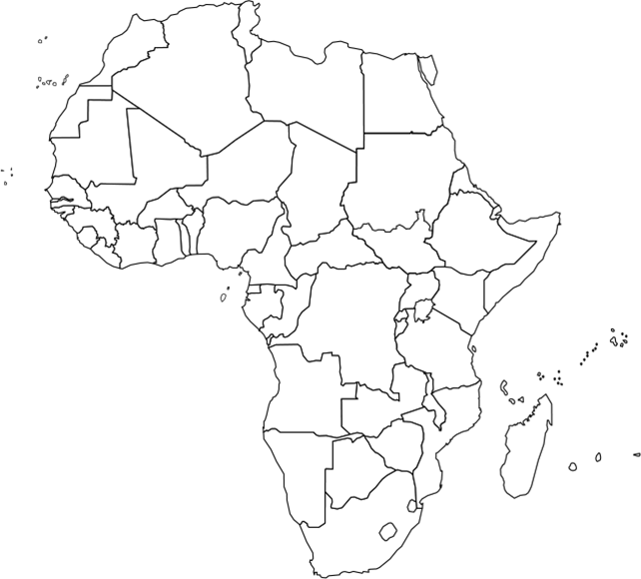

Sub-Saharan Africa – PHYSICAL Map

