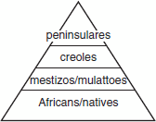
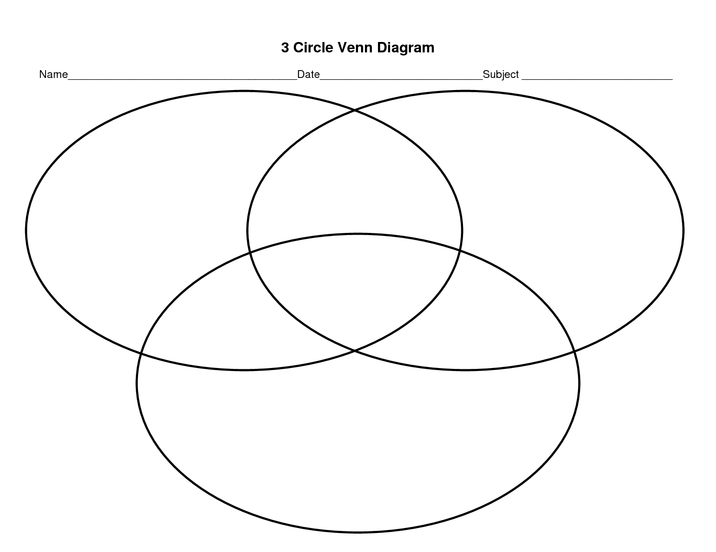
Culture of Latin America: Art, History, Religious Groups, Ethnic Groups

Spanish South America
Central America & Caribbean

Brazil
Write a 2-sided Poem/Rap/Song from
2 different points of view (Peninsular or Creole/Mestizo/African/Native)
on the SAME topic (life in ________________). Each should include information from your reading & Venn-Diagram and be at least 8 lines long

Point of View: Point of View:
____________________ __________________

