Brazil
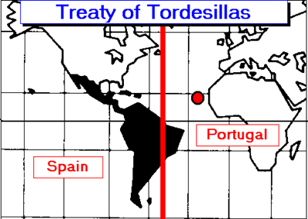
Geography played an important role in the colonization of South America by Spain and Portugal. The 2 European powers reached an agreement to divide South America in the resulting Treaty of Tordesillas (1494). Portugal gained control of what we now call Brazil. The territory was originally home to native peoples divided into hundreds, even millions, of tribes and language groups isolated by the dense Amazon Rainforest. The first Portuguese colonists hoped to find gold or silver, but were disappointed when neither were around, so they cleared the jungles to create massive sugar plantations. Brazil soon became a source of Portuguese wealth because demand for sugar was so great.
The patterns of settlement were along the coast, rather than in the interior, because the Amazon Rainforest made farming difficult. Eventually, the Portuguese conquered the native tribes and put them to work on plantations. When natives died from disease, they imported African slaves. An estimated four million slaves who were brought to the country over a 300-year period, at least four times as many as to the United States. Brazil was the last country to abolish (make illegal) the slave trade in 1888.
Today, Brazilians are a true blend of African, European, and Native ancestry. Today, only about 200,000 people live in the Amazon rainforest. Brazil has become home to many immigrants from other nations. Large numbers of people from Portugal, Germany, Italy, and Spain have settled there, as well as immigrants from Lebanon and Syria. Brazil also has the largest Japanese population outside of Japan! More than half of Brazilians now identify themselves as black or Mestizo (of mixed race), according to the latest census.
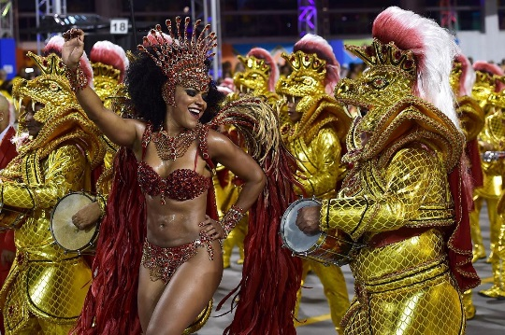
The Portuguese brought their language and their Catholic religion with them to Brazil. Today, Brazil has the largest Catholic population in the world. In addition, Protestants make up about 20% of the population. Many other Brazilians, mainly those of African or mixed ancestry, practice religions that combine African beliefs with Catholicism.
Brazil is a country of great variety in its city life, music, and holidays. The most colorful feast day in Brazil is Carnival (“Mardi Gras” in the USA). In Rio de Janiero, people in costumes ride on floats through eh streets. Carnival takes place to the music of the samba, a Brazilian dance with African influences.
Capoeira is a martial art and dance that developed in Brazil from African origins. Angolans who were taken to Brazil by the Portuguese brought this unique blend with them. It was originally used to train slaves to fight against their masters. Some groups were so successful that they created Quilomo, free slave colonies, even 100 years before slavery was deemed illegal. Quilombo communities continue across Brazil to this day.
Even many of Brazil's Catholic saints are said to have African heritage. St Benedict was a slave from North Africa who promised to devote himself to Catholicism if he became a free man. Brazil's patron saint, Our Lady of Aparecida, is a vision of the mother of Jesus as black who brought hope by runaway slaves on their way to Quilombo.
Brasília is the political of Brazil, and São Paulo is its economic heart and largest city, but Rio de Janiero is the cultural center. The residents of Rio are among the country’s leaders in important cultural activities and institutions. There is a darker side to life in Rio, though, and that is caused by the widening gap between rich and poor. Desperately poor slums, called Favelas, dot the hillsides.

